# CONCISE CHESS

## Contents

* Introduction
* Getting to Know the Chessboard
* Getting to Know the Pieces
* Check and Checkmate
* Castling, Pawn Promotion and En Passant
* Chess Notation
* How the Game Ends
* Checkmating Methods and Patterns
* Attacking and Defending Pieces
* Tactics
* Opening Play
* Thinking Ahead
* What to do Next
* These Are Just Notes On The Text, So Read It With The Text

## INTRODUCTION

* This book is exactly as the title says, it’s simple and concise, but it possibly covers everything needed to start
* it doesn’t need any prior knowledge
* the level of difficulty rises by the chapter

### FASCINATION

* Practice is generally rewarded, and improvement can be easily gauged by results
* the game could be quite addictive
* and it doesn’t require an element of luck
* chess isn’t something you’d have to retire from

### HOW THE GAME IS PLAYED

* There are 64 squares on a board
* each player has 16 pieces, so 32 in general
* the aim of the game is to trap your enemy’s king (checkmate)
* in competitive games a chess clock is used, it isn’t compulsary in friendlies
* if your alloted time runs out while you’re losing in material you lose

# CHAPTER ONE

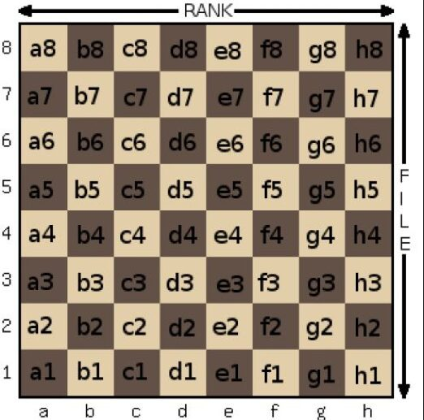

## GETTING TO KNOW THE CHESS BOARD

* It comprises of 64 squares
* We’d refer to the squares as light and dark squares, and the pieces as white and black

### The Board and Its Coordinates

* The squares at the bottom right and top left are always light squares; so h1 and a8 are light squares
* conversely the squares at the bottom left and top right are dark squares; so a1 and h8 are dark squares
* The numbers and letters at the sides and bottom are a coordinate system that acts as a reference map when discussing individual squares.
* The normal convention is to show the board from white’s point of view, White plays up the board
* odd and odd / even and even are dark squares
* odd and even / even and odd are light squares

### Ranks and Files

* the lines of squares going horizontally are known as ranks. e.g. 1st rank, 3rd rank
* the lines of squares travelling vertically are known as files. e.g. a file, d file

### Sectors of the Board

* For descriptive purposes the board is shared into two halves; Looking from white’s point of view (So it should be the opposite from black’s point of view)
  + the left side (a, b, c , and d files) is known as the queen’s side
  + the right side (e, f, g, and h files) is known as the king’s side
* always be conscious of how big the board is, so in essence always be conscious of the boundaries of the board and how close or far you are from them, there are also other important areas to keep an eye for that should also help for better coordination, like the center squates and others i should learn down the line.
* All squares on the 1st rank, 8th rank, the entirety of the a file, and the entirety of the h file make the boundaries of the board

# CHAPTER TWO

## GETTING TO KNOW THE PIECES

### Introducing the Rook

* This is the easiest piece to understand
* castle is an improper name for the look
* The rook moves horizontally and vertically
* For visualization purposes: a rook on d4 can access;
  + vertically; d1 through d8
  + horizontally; a4 through h4

so vertically the letters stay constant, while horizontally the numbers stay constant

* it captures in the same way that it moves

### **Introducing the Bishop**

* It’s a tall piece, and it’s top is shaped like a mitre
* it moves diagonally in any direction
* using the square the bishop is as an origin point(know what color of a square it’s on so you know what options are available to you), calculate how many files are left to both sides of the bishop and cross reference it to possible important locations, also check other important facts about it’s location like what color of a square is it on and the possible boundary squares available to it , should help with better visualization on how far it could go .e.g. a bishop on f4
* it captures in the same way that it moves

#### The Two Bishops

* Each player begins the game with two bishops
* one operates on the light squares, while the other operates on the dark squares
* A bishop on it’s own only has the potential to cover half the board, whilst a pair has the potential to cover the whole board

### **Introducing the Queen**

* The queen is the second tallest piece on the board (second only to the king)
* with a crown at it’s top
* the queen combines the powers of the rook and the bishop, so it can move in all possible directions, so once comfortable with the visualization of the rook and bishop combine their powers
* it captures in the same way that it moves

### Introducing the King

* The king is the most important piece on the board
* it’s also the tallest piece
* it has a cross at it’s top
* it moves one square at a time in any direction
* it also captures in the same way as it moves

### Introducing the Pawn

* The pawn is the lowiest and smallest of the pieces
* each player begins with 8 pawns on either the 2nd or 7th ranks
* pawns move vertically (but only forward and not backwards)
* they move one step at a time, except on the 1st move when they have the option of moving 1 or 2 squares
* it doesn’t capture in the same way that it moves, rather it captures only one square diagonally forward, even on the first move

### Introducing the Knight

* A knight not on the edge, and not blocked by a piece of it’s own, has access to a total of 8 squares, e.g. a knight on d4
* it moves in an L shape
* it can jump over it’s own pieces, and enemy pieces in it’s path
* it can access the immediate 2 files and 2 ranks around it, so a general of 4 ranks and 4 files
  + for the immediate files around it, it moves by 2 ranks
  + for the immediate ranks around it, it moves by 2 filess
  + so a knight on f5 can reach d4, d6, e3, e7, g3, g7, h4, h6
  + so it can access 2 squares on the same rank, and 2 squares on the same file
* it captures in the exact same way it moves
* if the knight begins on a light or dark colored square it always ends on a square of the opposite color

### The Pieces: A Summary

* The queen and rook are the most powerful pieces and are known as the major pieces
* the bishop and knight are of similar strength and are known as minor pieces
* the pawns are the weakest pieces on the board but they make up for it in numbers, and can also be promoted
* the king is a relatively weak piece but also the most valuable piece on the board
* in their starting position, the queen is always on a square of the same colour
* the unit of measurement for chess is moves, so always pay attention to how many moves needed to checkmate/stalemate, how many moves available in a certain position, how many moves it took to play a game...
* On an open board the rook always has 14 possible moves available, regardless of where it is positoned
* this is a note, not a new textbook, the most important thing to note are key facts and ideas

# CHAPTER THREE

## CHECK AND CHECKMATE

* When the King is attacked by an enemy piece this is known as ‘check’, on the next move, the player must take steps to get the king out of check; as they wouldn’t be allowed to do anything else before they deal with the threat to capture their king.

## GETTING OUT OF CHECK

* Moving the king out of check, simplest way to get out of check
* Capturing the checking piece
* Blocking the line of fire

## CHECKMATE

* When there is no way out of check, it’s checkmate.
* This is the aim of the game, the aim of the game is to check the opponent’s king
* it’s worth familiarizing yourself with checkmate patterns
* you use a check to checkmate, as a checkmate is when there is no way out of check, so it’s lowkey a check with no way out
* there is only one checkmate in a game
* if a player misses to see they’re in check and makes a move regardless, that move must be taken back and the player must make a move to get out of check

## Exercises

* I need to train an eye for checks and poisoned squares, it should help lessen blunders, help build an eye for checks and in extension checkmates, also help build an eye for tactics, but what exactly are poisoned squares?, and how exactly can i spot them?
* I should probably make a seperate note for game analysis, this analysis should entail ideas behind certain moves, alternative ideas, correction of blunders and why, and note to self, so kinda like a study note based on my own games

# CHAPTER FOUR

## CASTLING, PAWN PROMOTION AND EN PASSANT

* **Castling:** It is generally used to safeguard the king and to speed up the development process of the pieces
* **Pawn Promotion:** It enhances the importance of the lowly soldiers, because of this rule, a single extra pawn can mean the difference between success and failure
* **En Passant:** (French for in passing) is a variation of a pawn capture that was introduced to prevent games becoming too blocked up by chains of pawns

## CASTLING

* The process of castling is that the king moves two squares towards the rook and the rook hops over the king and lands one square beyond.
* Castling is always performed on the backrank and can occur on both the kingside and the queenside.
* For castling to take place, the squares between the king and the rook must be empty
* As white the kingside is towards your right, and as black it’s toward your left

### When Castling Isn’t Allowed

* The are two instances in which you aren’t allowed to castle:
  1. If your king is already in check, steps through check(the square it moves over while castling is poisoned) or lands on a checking square in the act of castling
  2. if either your king or rook has previous moved
* be able to tell the kinda check that stops you from castling

## PAWN PROMOTION

* If a pawn reaches the final rank of the board, you can promote it to a piece of your choice.
* Most cases a player chooses a queen but there are occasion in which it is more beneficial to choose a lower ranked piece(this is sometimes called under-promotion)
* the pawn can either move forward to promotion, or capture diagonally to promotion

### Rules of Pawn Promotion

* You can promote to any piece of your choice regardless of how many of the desired piece you have, in theory you can even have up to 9 queens
* An upside down rook is most times used to symbolize a promoted queen
* Although you can promote a pawn to any piece of your choice, it’s not permissible for a pawn to promote to a king
* and obviously a pawn isn’t allowed to be promoted into an enemy piece
* Finally, a pawn is not allowed to sit on the backrank unpromoted, it must promote to something

## EN PASSANT

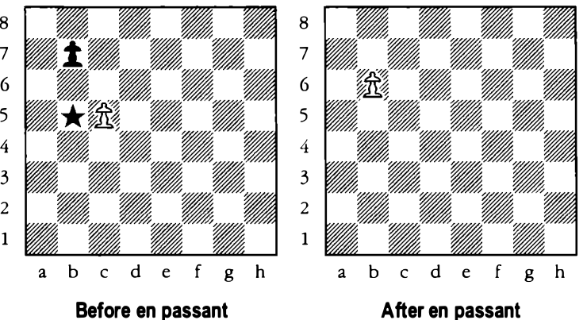

* En passant occurs when a pawn from it’s original position, moves two squares forward and finds adjacent (beside) to an opposing pawn, that enemy pawn then has (for one move only) the option of capturing this pawn as if it had only moved one square
* if one fails to note and play the enpassant on the immediate move it occurs, then the opportunity is gone forever
* it could get tricky as one has to remember the immediate move played when noticing the en passant pattern, to know if it is an en passant opportunity or not, as the rules specifically state that to allow en passant the pawn must be moved from the second to the forth rank
* 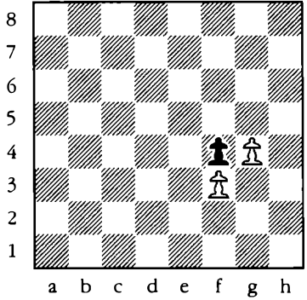
* so seeing to opposite pawns side by side two ranks from the pawn starting position is the en passant pattern, so the next thing is to remember the previous position of the pawn to know if it’s possible or not

## Exercises

* Even if the rook is being attacked, castling is still possible. It’s the king’s path that is crucial - not the rook’s

# CHAPTER FIVE

## CHESS NOTATION

* This is a beneficial exercise because it allows you to play through games at a later date, either to identify crucial moments, good moves and mistakes or simply to enjoy again at your leisure a pleasing win
* and it isn’t limited to just your games, understanding chess notation allows you to play through, enjoy and learn from games played and annotated by the world’s best players.
* The virtually universal chess notation used today is the algebraic notation, and it’s easy to understand
* Train and practice **algebraic** notation, by thinking up random positions and spotting them on an empty board

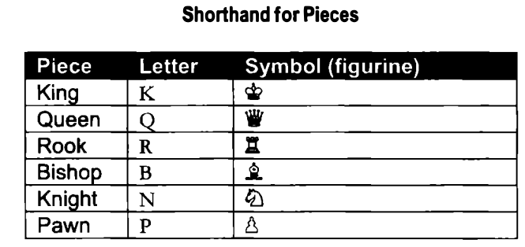

* The table above is pretty straightforward
* queen to a4 is recorded as Qa4
* so algebraic notation works by either stating the letter or symbol of the piece followed by the coordinate of the move
* for no obvious reason tho, although the pawn has a letter and symbol assigned to it, these are actually not used in notation.
* Thus a pawn moving from a4 to a5 would simply be recorded as a5, not Pa5

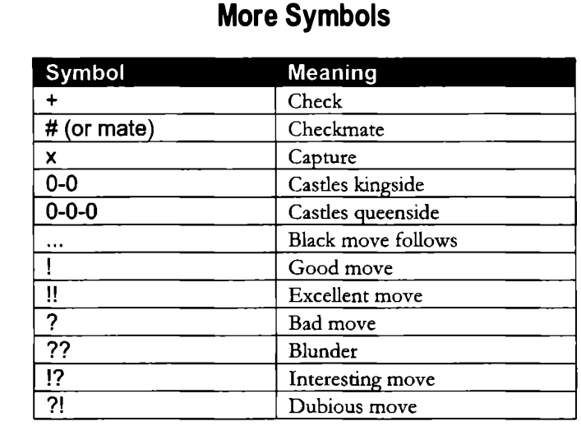

* The last 6 symbols of the table aren’t compulsory, they’re just used by annotators to economically describe the quality of certain moves

### NOTATION IN ACTION

* **1 e4 :** the number preceding the move indicate the first move, 3rd , or last move of the game
* **1 ...e5 :** the three preceding dots indicate that it’s black’s move
* easiest way to get used to chess notation is go through sample games, so kinda like practice makes perfect i guess.

### NOTATION FOR AMBIGUOUS MOVES

* In case of two connected rooks on the same rank, it would be rather ambiguous to write Re1, as you wouldn’t know which rook it refers to, so to fix this we write file it was on to the file it moves to .e.g. Rae1
* In some cases where the piece like the night is on the same file, writing Nfxe5 would still be ambiguous, in such cases instead of the file, the rank would serve as reference .e.g. N7xe5

## Exercises

* When a pawn is promoted it should be denoted by the normal notation followed by the piece it’s being promoted into .e.g. a8Q
* in ambiguous cases where it can be clarified both by file and rank, clarification by file takes precedence
* Even during an enpassant the move order would be recorded as a usual capture .e.g. cxb6

# CHAPTER SIX

## HOW THE GAME ENDS

* A game can either end in a win, loss or a draw
* A win can either be by resignation of an opponent, or checkmate
* There are 3 ways to earn a draw:
  + Stalemate
  + Perpetual Check
  + Draw by Agreement
* When players get more experienced, they do not need to wait for the game to end in checkmate.
* When playing as a beginner, it’s adviceable not to resign, as stalemate might still possible
* Stalemate occurs when one player, whose turn it is to move and who’s not in check, but has no legal way of continuing.If this happens the game ends in a draw
* For stalemate to occur, the lucky player doesn’t necessarily have to be down to a bare king.

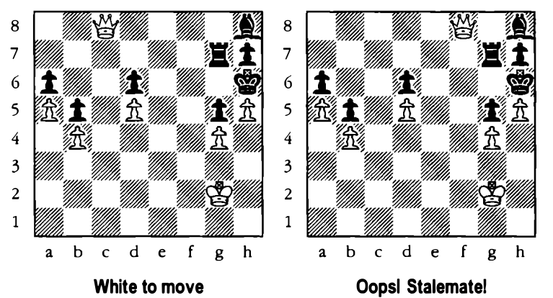

* **Perpetual check** is a situation in chess where one player can give a series of checks repeatedly without the other player being able to escape. This often leads to a **draw**, especially when:
  + The checking player has no way to win otherwise.
  + The only way to stop the checks would be to expose the king to further checks again.

It’s commonly used as a **defensive tactic** to save a losing or equal position. While perpetual check is not a formal rule in itself, it often results in a draw by **threefold repetition** or **mutual agreement**.

* When both players are also left with only their kings on the board, this is a draw
* Another way to draw is by agreement, this is especially adviced when facing a deadlocked position

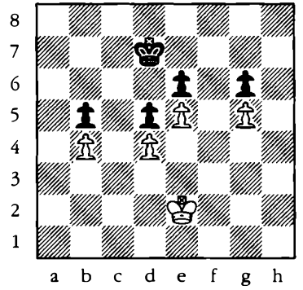

* Between more experienced players, mutual agreement is probably the most common way for a game to end in a draw, However it’s advised for beginners and inexperienced players to avoid offering draws and to play to a natural conclusion
* There is much to be learnt by playing these simplified endgames and besides your opponent might not play perfectly and blunder

## THE TOUCH MOVE RULE

* One rule to be adhered to in competitive play is the touch move rule. If a player whose turn it is touches a certain piece, he is obliged to move that piece if he can do so legally. This is more of an over the board rule
* If you wish to adjust a piece on its square, you should precede this action by saying **J’adoube (**French for I adjust**)**

### STALEMATE PATTERNS

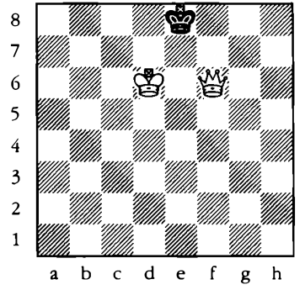

* if the queen makes some kind of right angled triangle with a king at an edge, and it’s the king to move, it boxes out the king, not allowing the king make another move, which could definitly lead to stalemate
* that’s a single pattern, make sure not to box out the queen

# CHAPTER SEVEN

## CHECKMATING METHODS AND PATTERNS

* Chekmating methods, and checkmating patterns are two different things
* We’d only focus on the most common checkmating patterns
* In the consecutive chapter 8 and 9 we’d be dealing with how to win pieces and exploit material advantage
* however it’s necessary to notice that material advantage often leads to a position in which you have to checkmate a bare king, the most common scenarios are:
  + king and queen versus king
  + king and two rooks versus king
  + kind and rook versus king
* There are obviously hundreds of ways to set up checkamting positions, but some mating patterns crop up timt and time again, so it’s definitely worth familiarizing with these
* There are also some tricky checkmate that arise early on in the game, it’d be quite advantageous to learn these and their antidotes

## Checkmating With King And Queen Versus King

* Box (confine the enemy king to one of the edges of the board) of the enemy king using the queen only, be careful enough not to make the box too small for fears of stalemate, and also don’t check the king while trying to box it in or you’d end up letting it escape

## Beware Of Stalemate!

* Be careful not to box out the king if you aren’t delivering checkmate, as that can always lead to stalemate

## Checkmating With The King And Two Rooks Versus King

* For this a ladder (lawn mower)checkmate will suffice, that’s cutting of the rows the king has access to, and checking with the other rook, and anytime a rook is attacked just slide to the other end of the board
* even if the rooks are awkwardly placed, just remember you have four sides, and figure their placement for the easiest checkmate

## Checkmating With King And Rook Versus King

* This one’s more complex than the previous ones, as with the king and queen the idea is to force the opposing king into a corner, however the rook cannot do this on it’s own, it needs the king’s help, this plan has three stages
  1. bring the king and rook close together
  2. to force the king into a 2 by 1 box in the corner, on each move you should make the box smaller if possible, if this isn’t possible improve the positiion of the king, if neither is possible make a waiting move with the king
  3. through this process never check the king, lest it escapes
  4. 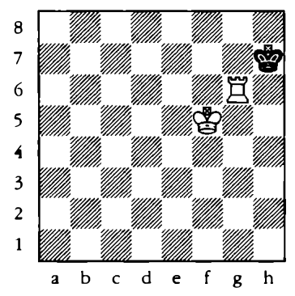 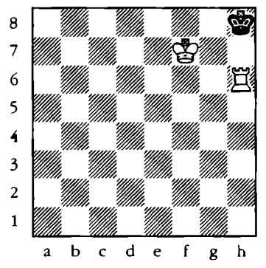
  5. once it’s been covered into a 2 by 1 square, get the king to cover the crucial squares, and then deliver mate

## Fool’s Mate And Scholar’s Mate

* There are a couple of checkmates that can arise very quickly from the starting position: fool’s mate and scholar’s mate
* fool’s mate is the quickest possible checkmate from the starting position – there are only two moves from both sides
  + **1 f3? :** A bad move, which does noth­ing for development and exposes the king (we will deal with open­ing play in more detail in Chapter 10)
  + **1...e5 2 g4:** this is a thousand times worse than white’s first move – it allows an immediate checkmate
  + **2... Qh4 mate**!: Annoyingly true

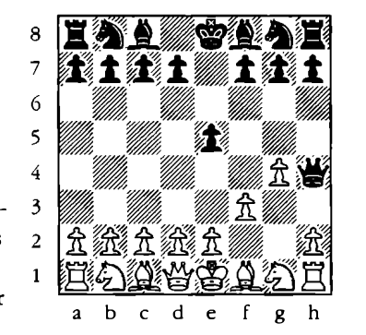

* fool’s mate is hardly ever seen as it need so much corporation from the white player.
* However Scholar’s mate is seen very frequently in beginner’s chess:
  + **1 e4 e5:** we’d later observe this opening sequence in more detail
  + **2 Qh5:** white goes straight for the kill, but be warned developing the queen too early is a major disadvantage
  + **2...Nc6**
  + **3 Bc4**
  + **3 ... Nf6**
  + **4 Q xf7 mate!**
* We will study threats and defences in more detail in chapter 8, but for black to escape the scholar’s mate, black must defend the pawn on f7 ( with say3... Qe7 or 3...Qf6 ) or block the route of one of the attackers( 3...g6 ), as the killing blow to the coffin was 3... Nf6
* 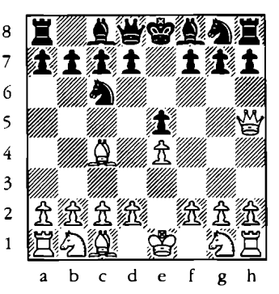 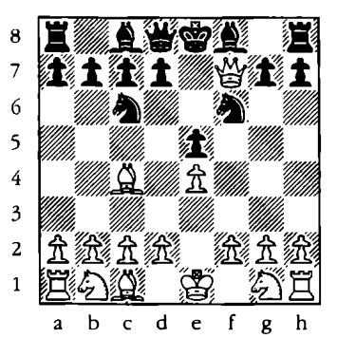

## BACKRANK MATES

* This checkmate is one of the dangers of castling (which is mainly for king safety ), as the pawns that cover the king from a frontal attack leads to it’s downfall

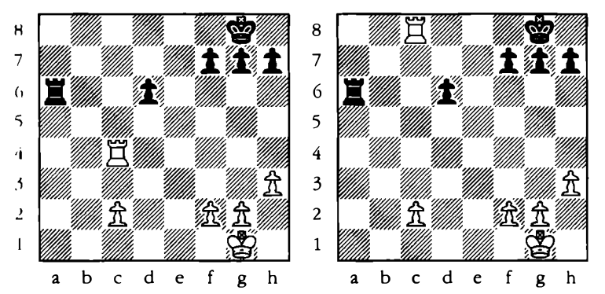

* easy ways to defend against this kind of checkmate are:
  + leaving a piece to defend the backrank
  + taking time out to move one of the three pawns

## CHECKMATING PATTERNS

### QUEEN CHECKMATES

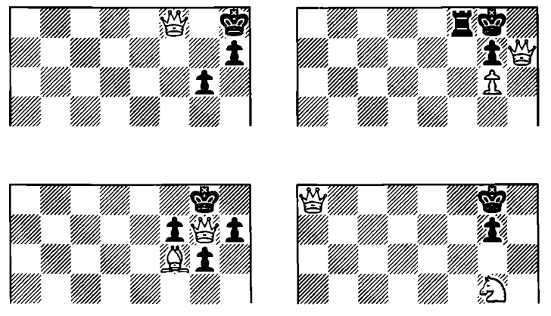

* In majority cases you’d notice the checkmated king on the back rank and the kingside, this is normal because most players tend to castle kingside at some point during the game

### ROOK CHECKMATES

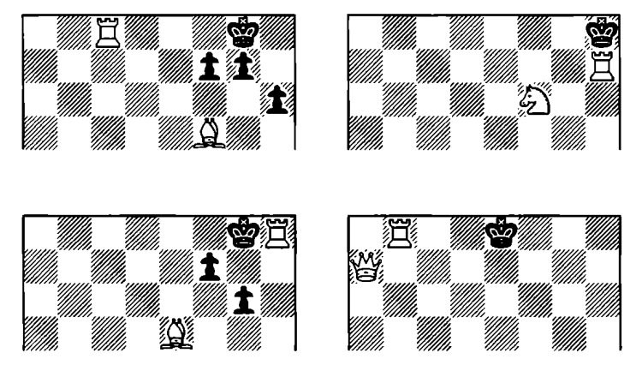

* these are four common rook checkmates:
  + the 1st is a variation of the back rank checkmate with the bishop covering the escape square
  + the 2nd is the bishop and the rook working together, and taking advantage of the board setup
  + the 3rd sees the knight and the rook combining to cover h7, g7, h8 and g8
  + the 4th is a variation of the lawnmower, but with a queen instead of a second rook

### BISHOP CHECKMATES

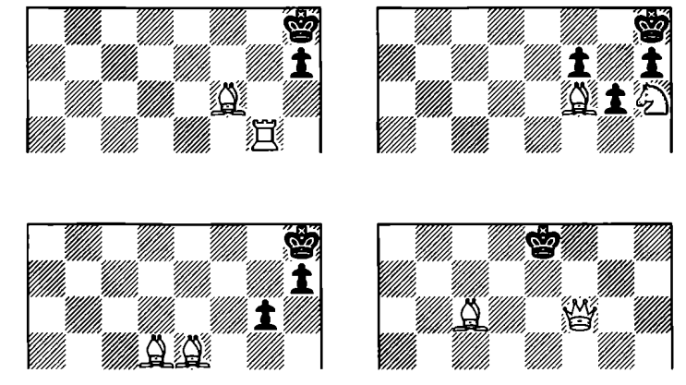

* These are four popular bishop checkmates:
  + the 1st diagram shows the rook and bishop with an enemy pawn delivering mate
  + the 2nd diagram shows the power of a bishop pair
  + the 3rd shows how the bishop and knight can combine to deliver mate in a popular position
  + the 4th shows how a bishop and queen can combine to deliver mate

### KNIGHT CHECKMATES

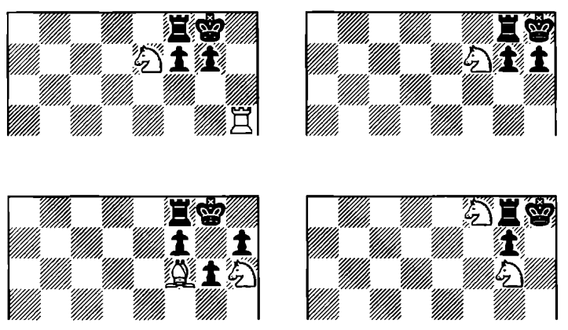

* What is a smothered mate?, it’s when your king get’s mated while being smothered to the edge of the board by it’s own pieces
* the patterns should be memorized and thought through

### PAWN CHECKMATES

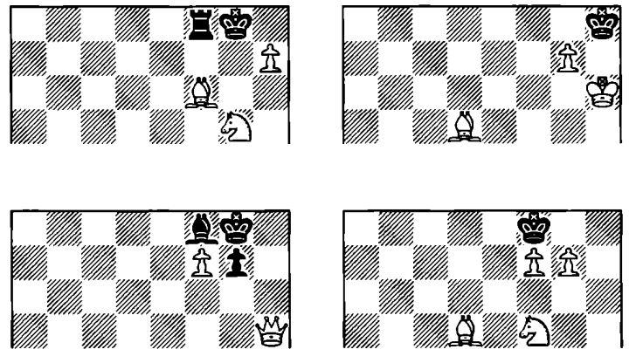

* These are very rare, but do pop up from time to time
* don’t wait to finish making the note to read through it

# CHAPTER EIGHT

## ATTACKING AND DEFENDING PIECES

* While checkmating might be the aim of the game, attempting this from te start of the game is unlikely to be a success – as the king is too well defended
* so checkmating is the ultimate aim but there are other aims, as a game isn’t strictly won by mate, there is the gradual elimination of opposing pieces: as when the king is open and devoid of protection, checkmate is easier to deliver
* The initial objective of the game is to capture opposing pieces while hanging to your own, as the game obeys the rolling effect; if you have more pieces than your opponent it’s going to be easier to win more pieces
* Ofcourse the quality of the pieces are just as important as the quantity
* A word of **warning:** even though we attempt giving numerical value to pieces, every position must be judged on its own merits; the queen might be most powerful piece but it will only display a percentage of its own power if it’s blocked by it’s own pieces or pawns

## THE MOBILITY OF PIECES ON AN OPEN BOARD

* Most pieces are more effective in the centre of the board than they are on the edge, they have control over more squares and better mobility

### COMPARING THE MOBILITY OF DIFFERENT PIECES

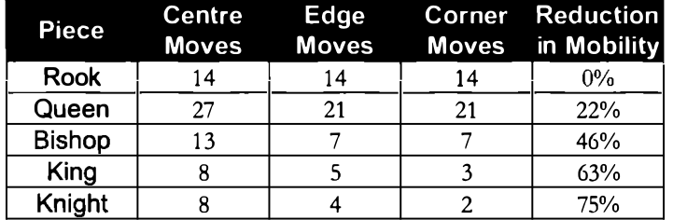

* This table is based on the assumption that the board is empty
* as on the table the rook isn’t affected, and the queen is barely affected
* while obviously the knight suffers most on the edges and corners; hence the maxim “a knight on the rim is grim”

## GIVING PIECES A NUMERICAL VALUE

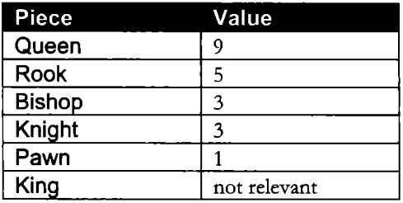

* This is the almost universally recognised numerical value of the pieces.
* Alhough the king’s value is the game, it’s only as powerful as a minor piece
* However it’s important to emphasize that values can change from position to position; e.g. in a blocked position a knight’s value may increase whilst a rook’s decreases, if a pawn is very close to promotion, then it’s value may increase

## SAFE MOVES

* Safe moves are moves that do not allow your opponent to gain material
* The ability to make safe moves is a fundamental skill that cannot be underestimated
* When making a move with a piece, at least two questions should be asked:
  + Can this piece now be captured by an opposing piece
  + Has this move opened the way for another of my pieces to be captured, as we’d see tho, this simplification doesn’t tell everything

### MAKING SAFE MOVES

* If making a move causes an exchange in which you gain more material advantage, then it’s a safe move, e.g. exchanging a knight for a rook
* obviously tho if the exchange leads to a loss in overall material, that’s a loss, e.g. a queen for a rook
* if you making a move leaves another piece undefended then this an unsafe move; most times by moving defending pieces

### THREATENING YOUR OPPONENT PIECES

* The next step would be making safe moves that carry threats,
* When we are left with an overall loss or gain of 0 – this is often referred to as an exchange or a trade, these are safe depending on strategy and position
* moving to attack an opposing piece from a safe yet undefended square is still a safe move, but might not be safe later through the game

### CAPTURING YOUR OPPONENT’S PIECES

* Another crucial skill is deciding which pieces to capture and which piece to leave alone
* use the textbook for this part, it’s very over the board example heavy
* A good but not a definitive guide as to whether a threatened piece should be captured is to subtract the numberr of pieces defending the threatened piece from the number of piece attacking it, if the answer is greater than zero then there is a good chance that the piece can be safely captured.
* If the number of pieces defending are not equal to the number of pieces attacking, then it’s not safe to capture

#### VALUE OF ATTACKERS VS VALUE OF DEFENDERS

* Unfortunately it’s not just a case of counting up the attackers and defenders, their values just are as important

#### CAPTURING IN THE CORRECT ORDER

* Always capture with less valuable pieces, otherwise you could end up with a loss in material after a series of exchange

## DEALING WITH THREATS TO PIECES

* This focuses on the importance of hanging on to your own pieces
* just as there are ways of getting out of check, there are numerous ways of dealing with a threat:
  + you can move the threatened piece
  + you can protect the threatened piece
  + you can capture the attacking piece
  + you can block the line of attack
  + you can counterattack
* There are more possibilities when dealing with a threatened piece in comparison to when the king is in check; as protecting the king when it is in check isn’t an option, neither is a counterattack
* if your piece is being attacked by a piece of lesser value, don’t consider defending the piece as this could lead to a loss in material
* When capturing an attacking piece remember to not make a trade if it will lead to a loss in material. Although capturing an attacking piece is considered a good option, when making exchanges always start with the least valuable pieces, and don’t make an exchange if it will lead to a loss in material
* When blocking an attack, always try to set it up to be defended so you don’t have a hanging piece, and try to use the least valuable piece to set this up
* A counterattack is when you attack a more valuable piece whilst you are under attack, forcing your opponent to take a defensive position and allowing you to save a hanged or smothered piece.
* Two more important question to ask before every move would be:
  + Which pieces can i capture?
  + Does my opponent have any threats?

# CHAPTER NINE

## TACTICS

* **"En prise"** is a French term used in chess that means **"in taking"** or **"in a position to be captured."** When a piece is en prise, it means it's left undefended and can be captured by an opponent on the next move.
* The higher you go in rating, the less the chances of you winning a game merely by threats or by your opponent blundering en prise, at this level you’d need tricks and traps; and this is called tactics and combinations
* tactics help you both win material and defend against your opponent’s tricks
* most of the ideas are straightforward and can be mastered by practice
* the most common tactics are forks, pins, and skewers
* It’s said that 99% of chess is tactics, and at most levels of the game, this is true

## THE FORK

* This one of the most fundamental tricks to use to win material
* A fork occurs when a piece attack two or more enemy pieces at the same time
* When two pieces are forked this is also commonly known as double attack

### FORKING CHECK

* Never have your king on the same file as another value piece, also watch for it; this is most times an opportunity for a tactical advantage
* When a fork is against a king, there’s less of a chance of counterattack

### FORKS WITH OTHER PIECE

* Unlike some tactics, forks can be carried out by any piece

### THE FAMILY FORK

* When a piece attacks more than two opposing pieces, this is known as a **family fork**, this is a specialty of the knight, which is particularly effective at sniffing forking possibilities

## PINS

* One of the most powerful available weapons.
* this occurs when you attack an opposing piece that cannot move off the line of attack without exposing a more valuable piece behind it.
* There are two types; pins against kings and normal pins
* Pinning a piece against a king is the most potent type of pin because the piece in question cannot move off the file or diagonal on which it’s pinned.

### ATTACKING THE PINNED PIECE

* Pinning a piece to a king is often referred to as an absolute pin
* if you pin a minor piece to the king using a major piece, and your opponent defends the pinned piece, you should build on the attack using the least valuable piece possible, so in a trade off you can have a win in material

### PINNING A MAJOR PIECE AGAINST A KING

* You can also pin major pieces to the king and force an exchange

### A Pinned Piece Loses its Power

* Even in situations where the pinned piece is protected sufficiently and cannot be captured favourably, the pinner may still be able to exploit the situation to his advantage
* It helps in cutting of the king to force a mate

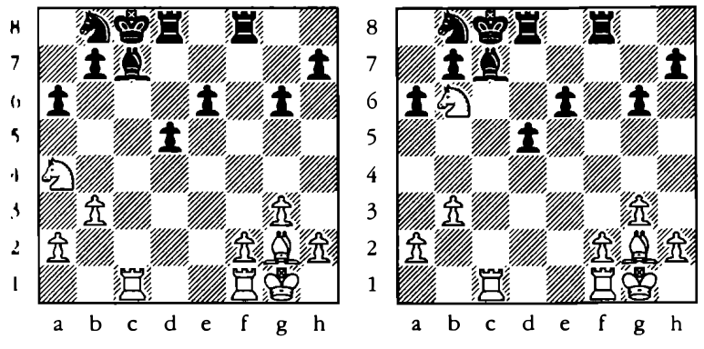

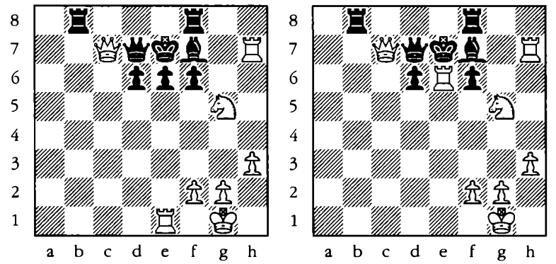

* In the second example, althought black seems well protected, but due to the pins it’s actually smothered, so i guess looks can be deceptive.

## NORMAL PINS

* A normal pin might not be as viscious as an absolute pin, but it’s still rather effective
* These are like pins against more valuable pieces.

### A PINNED PIECE DOESN’T PROTECT

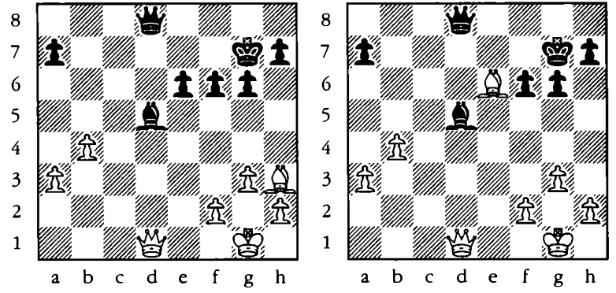

## THE SKEWER

* Like pins, skewers can only be achieved by long-range pieces, i.e queens, rooks and bishops
* A skewer is very similar to a pin, this occurs when you attack an opposing piece that cannot move off the line of attack without exposing a piece of equal or less value behind it

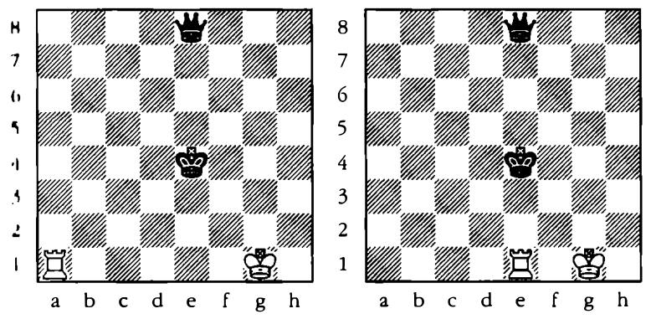

* Just as pinned pieces can be attacked with multiple pieces, a skewered piece can also be attacked with multiple pieces; when a piece is pinned or skewered, you can attack the pinned/skewered piece with a piece of lesser value, so as to use lesser piece for the exchange and get more material advantage.

## ATTACKING A DEFENDER

* Attacking a piece that is already defending another attacked piece can cause a defence to collapse. you are in effect, attacking the weakest link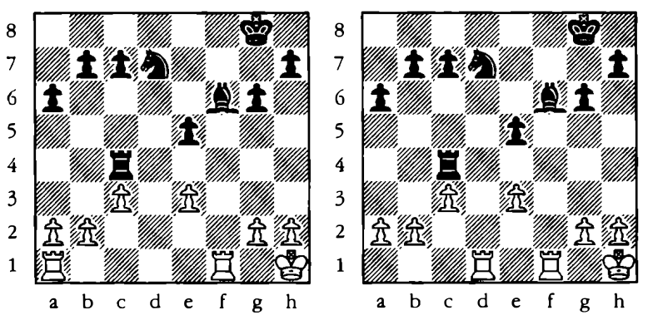

## ELIMINATING A DEFENDER

* Eliminating a defender, sometimes called ‘destroying the guard’ is going one stage further than the previous page and is useful on occasions when the defending piece can be protected

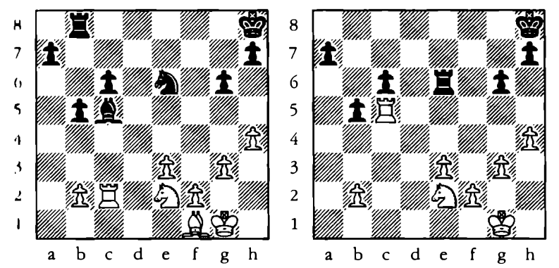

* if the defending piece is equally exchanged, it leaves the piece being defended for capture, so more material advantage

## THE DISCOVERED ATTACK